**Team MP 205**

Ayush Pant

Dominic Polcyn

Thien Tran

Kaitlyn Younger

The Color Glove

**Description:**

This product is designed to help visually impaired people get dressed in the morning by detecting the colors of different articles of clothing. There are lots of different times where throwing on a random t-shirt is not efficient, and you may need to match specific colors such as a black blazer and trousers. This product makes use of an ultrasonic sensor and RGB sensor within a glove to detect objects and deliver the detected color through a set of headphones. We also make use of a vibrator motor when the user is not yet close enough to an object and a simple on and off button. There are three finger holes that are cut free to allow the user to have fingers free to touch different fabrics. The power comes from a power bank within a fanny pack to allow more mobility. All other hardware is connected directly to the glove and is firmly sewed in to prevent knocking elements loose. The glove has an adjustable strap at the bottom to fit different hand sizes and to make sure the product is secure.

**Photos:**

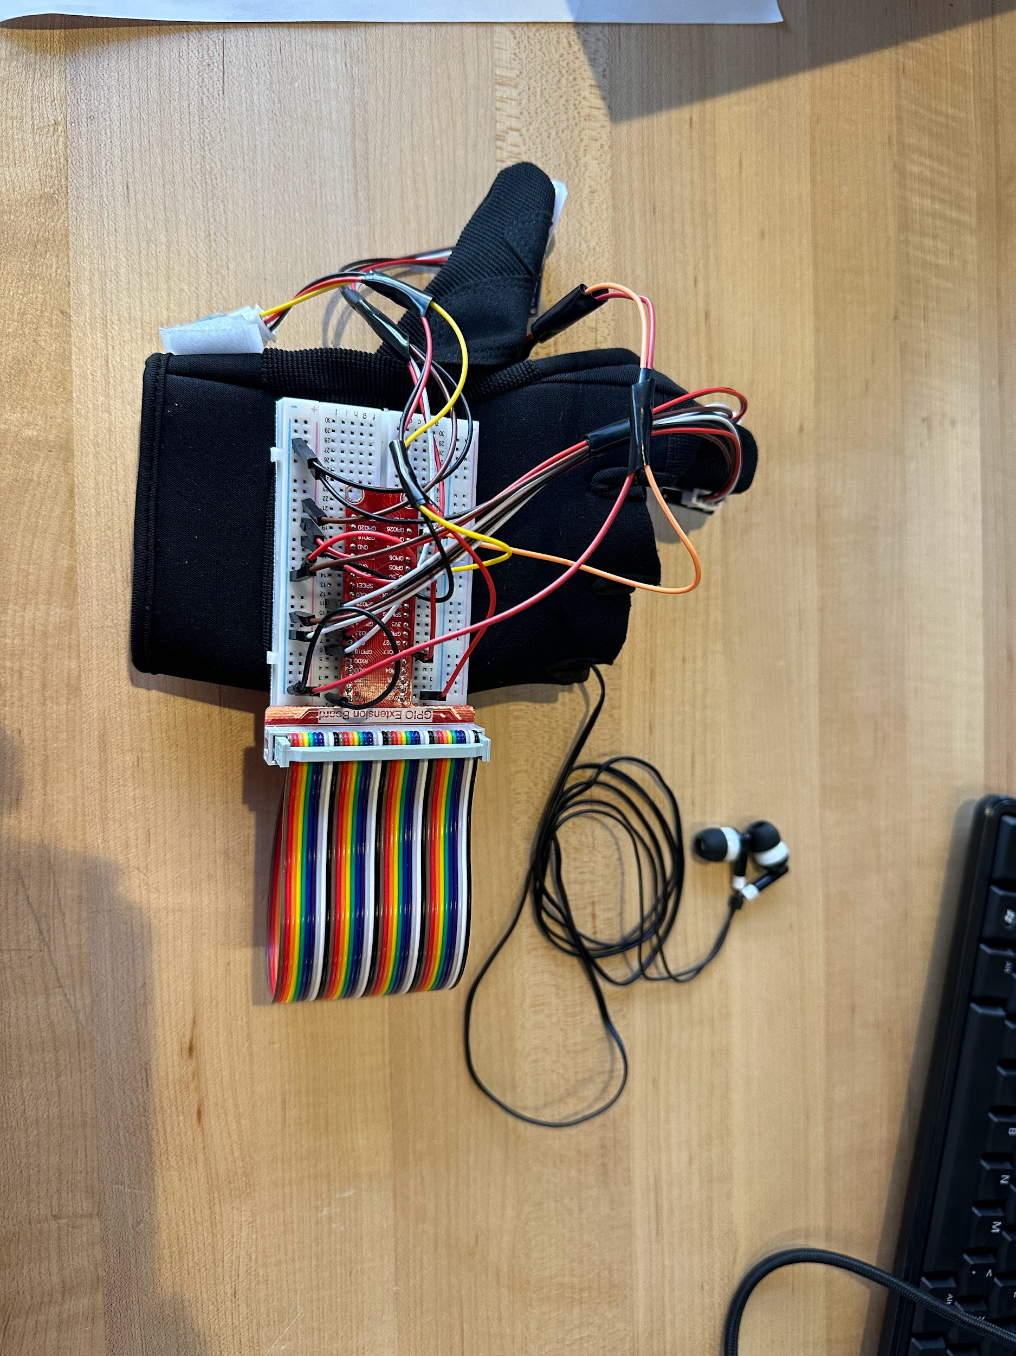

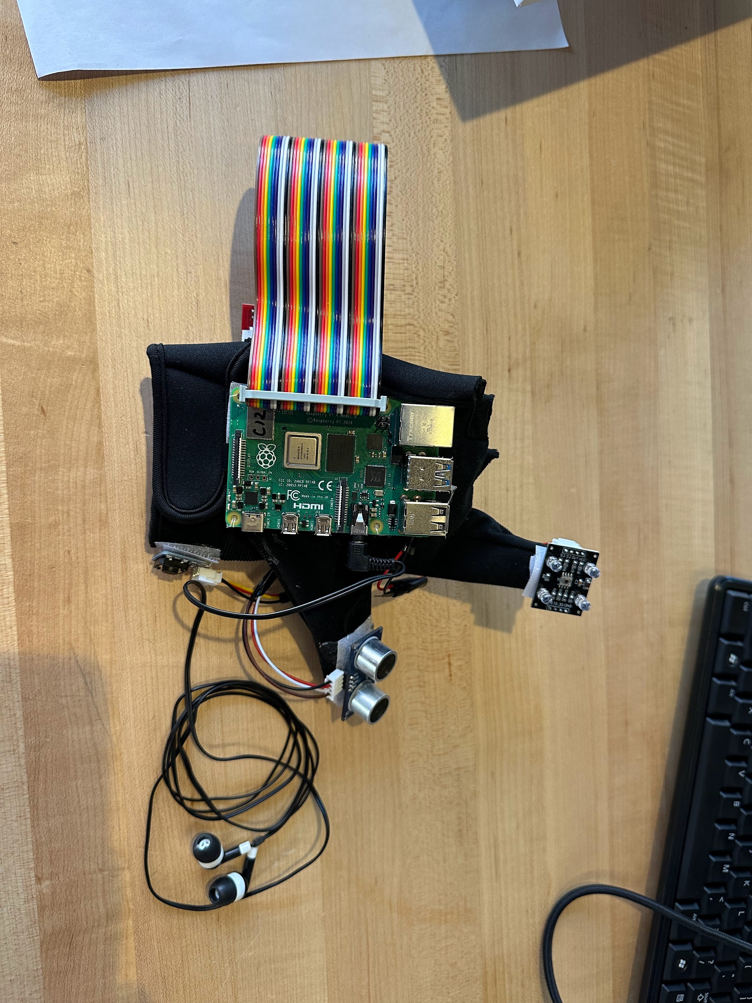

**Presentation:**

<https://docs.google.com/presentation/d/192az7InTRJ-rSoFYaVO2iTHjkGURc0QF/edit?usp=sharing&ouid=101160863970726712975&rtpof=true&sd=true>

**Video:**

[**https://youtu.be/5OW9Yai7LvM?si=2zzqf3o1ldIh64k0**](https://youtu.be/5OW9Yai7LvM?si=2zzqf3o1ldIh64k0)

**Zip File:**

<https://drive.google.com/file/d/1k9ri5zuYJuOctrGpKwox9TqXErjMz1Mj/view?usp=sharing>